* 1. **Planning & Scheduling**

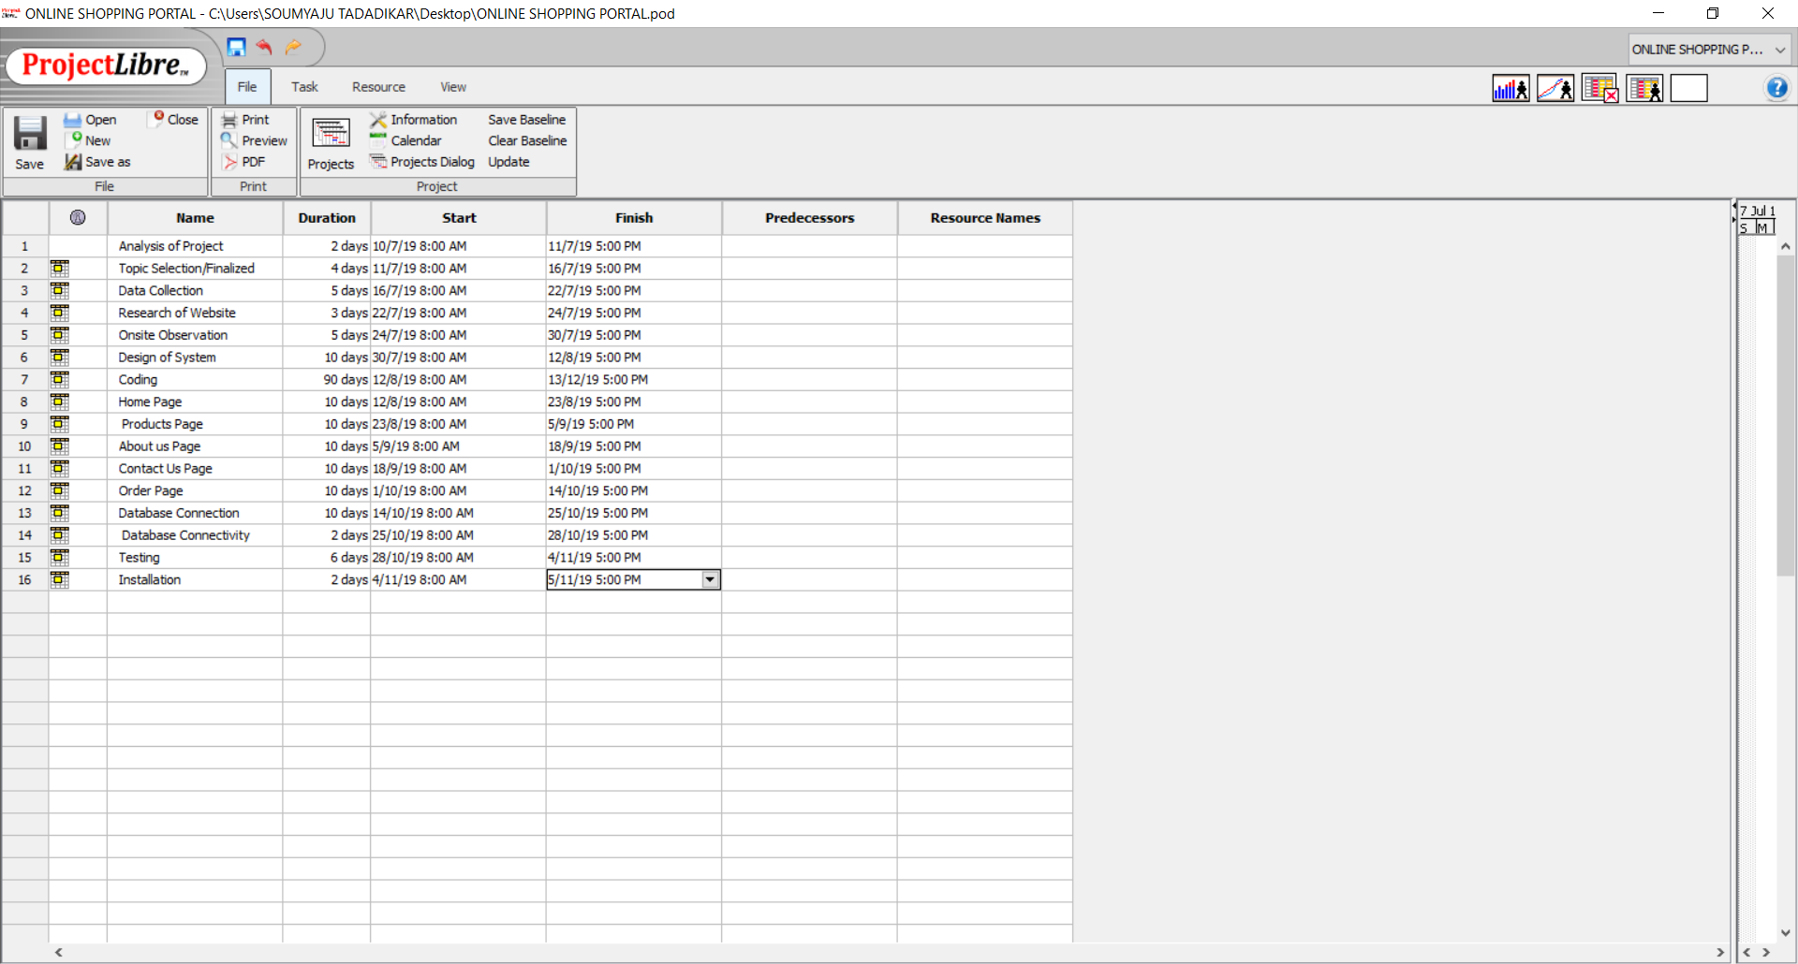

GANTT CHART :

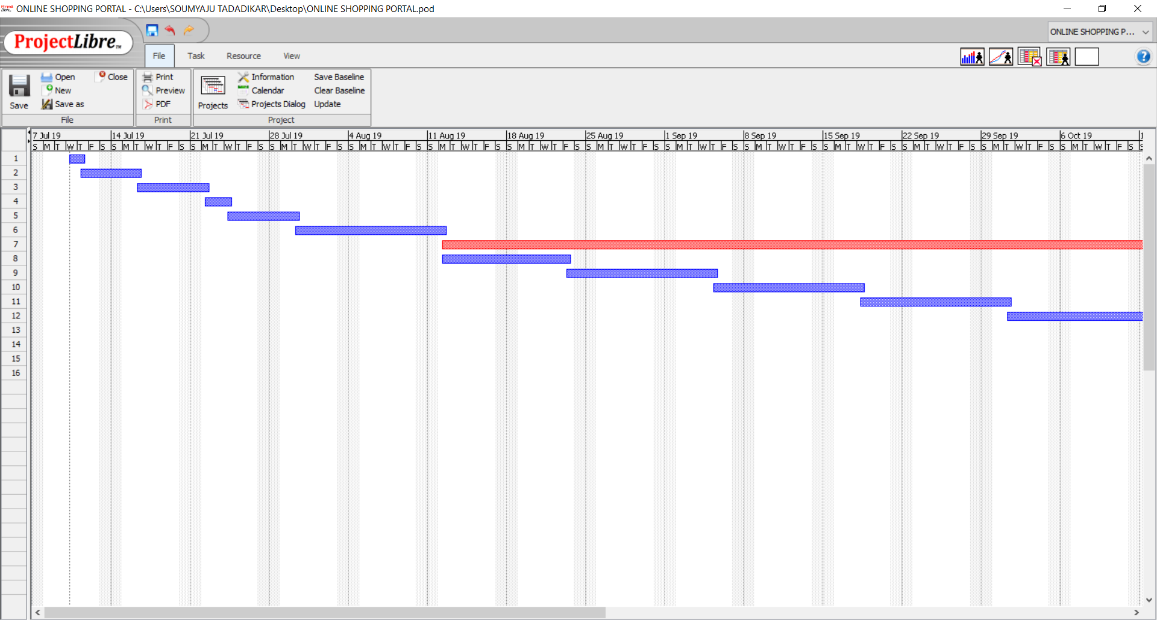

Fig.Gantt Chart 1

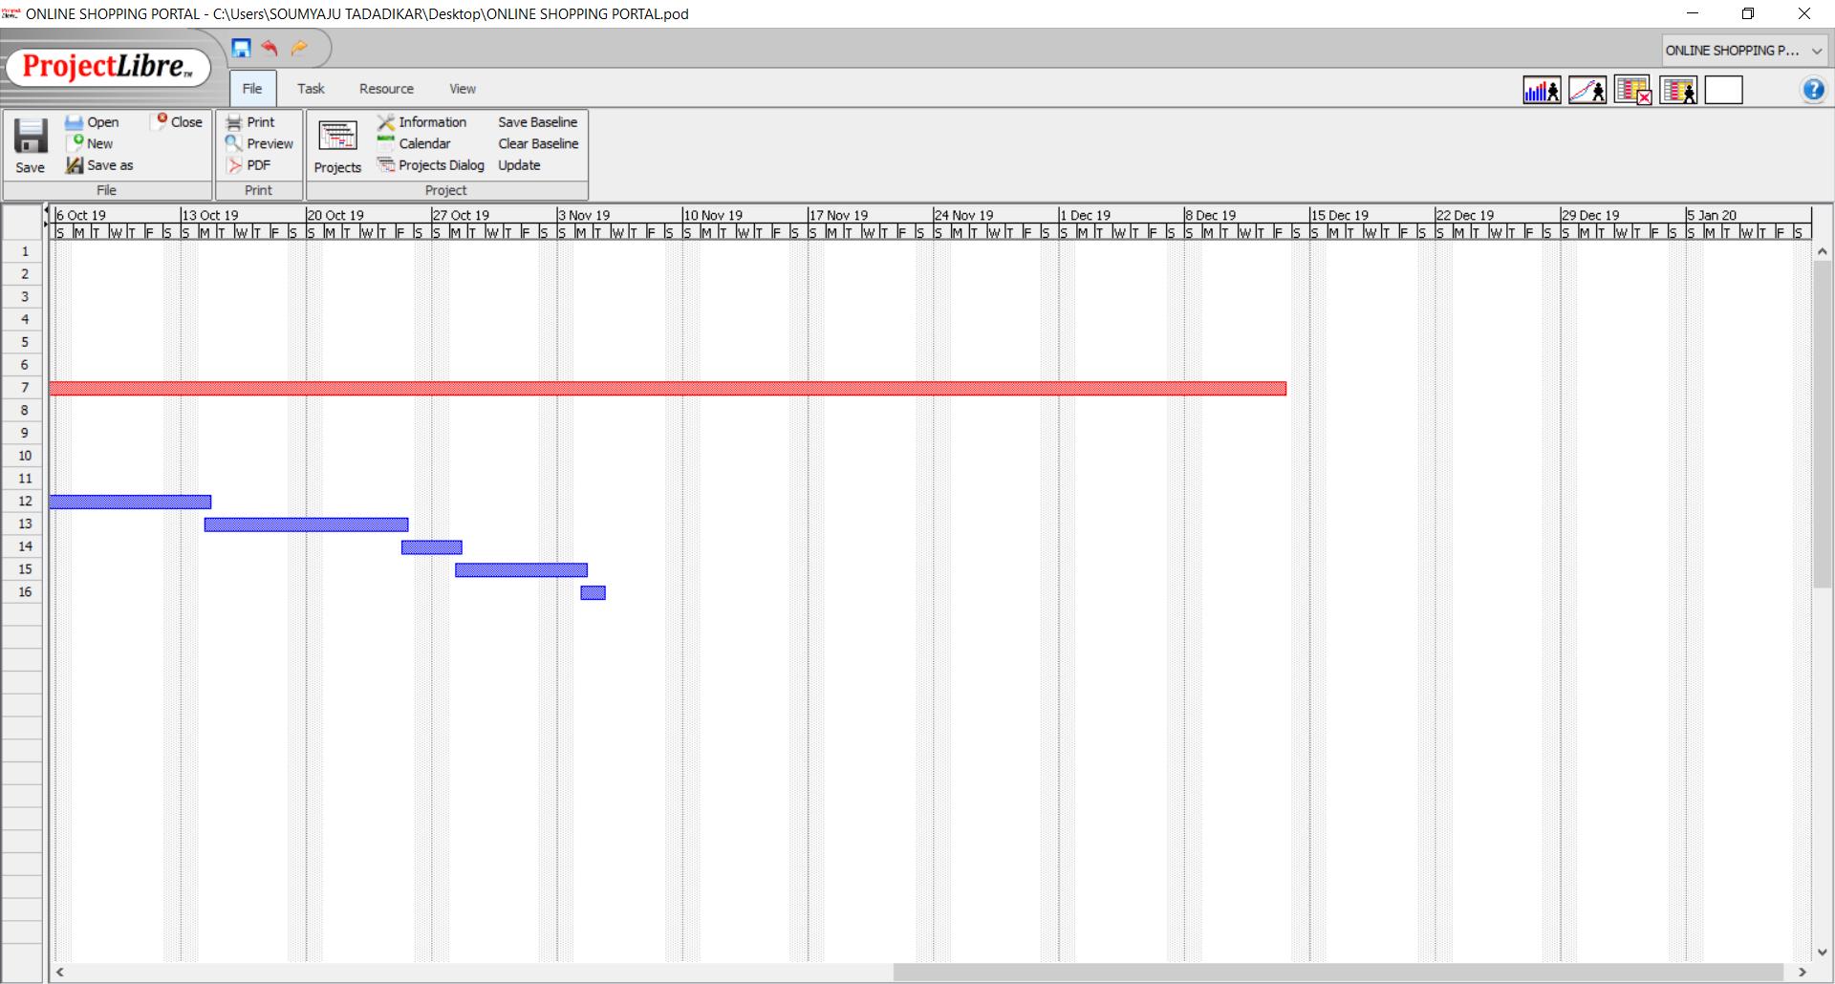

Fig.Gantt Chart 1